Report
on the Support Provided to International Students Studying at Uzbekistan State University of World Languages in the 2024–2025 Academic Year
Continuous support for international students is organized by the University administration and faculties.
All international students arriving at UzSWLU for studies are met at the international airport by responsible personnel and escorted to a hotel for teachers or a dormitory for students. In addition, continuous assistance is provided with visa and residence permit (JSHSHIR) processing, accommodation arrangements, and all organizational matters.
Work is being carried out in cooperation with language courses that prepare foreign applicants for admission to UzSUM.
Three Telegram groups have been created for working with international students: one for master’s students, one for first-year bachelor students, and a separate group for second- to fourth-year students. All announcements and questions are discussed within these groups. Student attendance is monitored through the dean’s office. Each faculty assigns a tutor and a local student to assist international students with translation and document-related matters.
In addition, international students are invited to participate in sports competitions held at the university. For example, Chu Chengxin, a first-year bachelor student, won first place in badminton.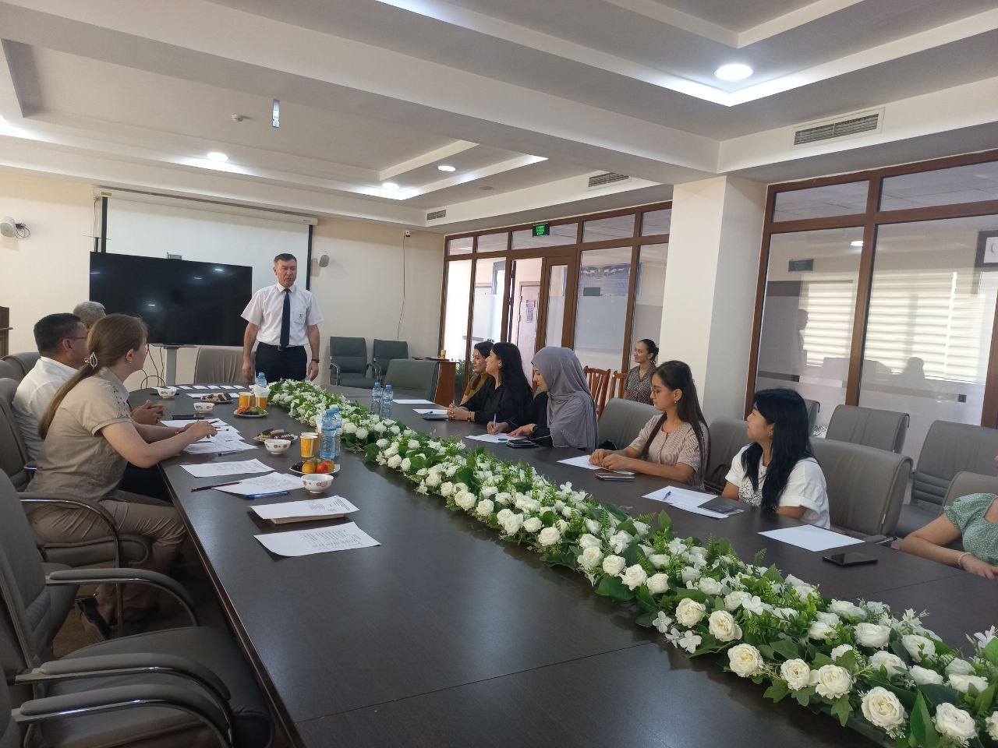

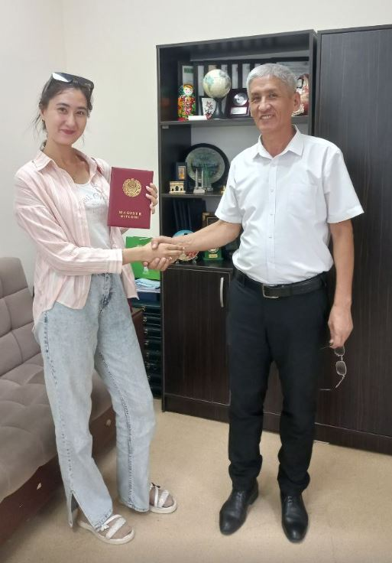

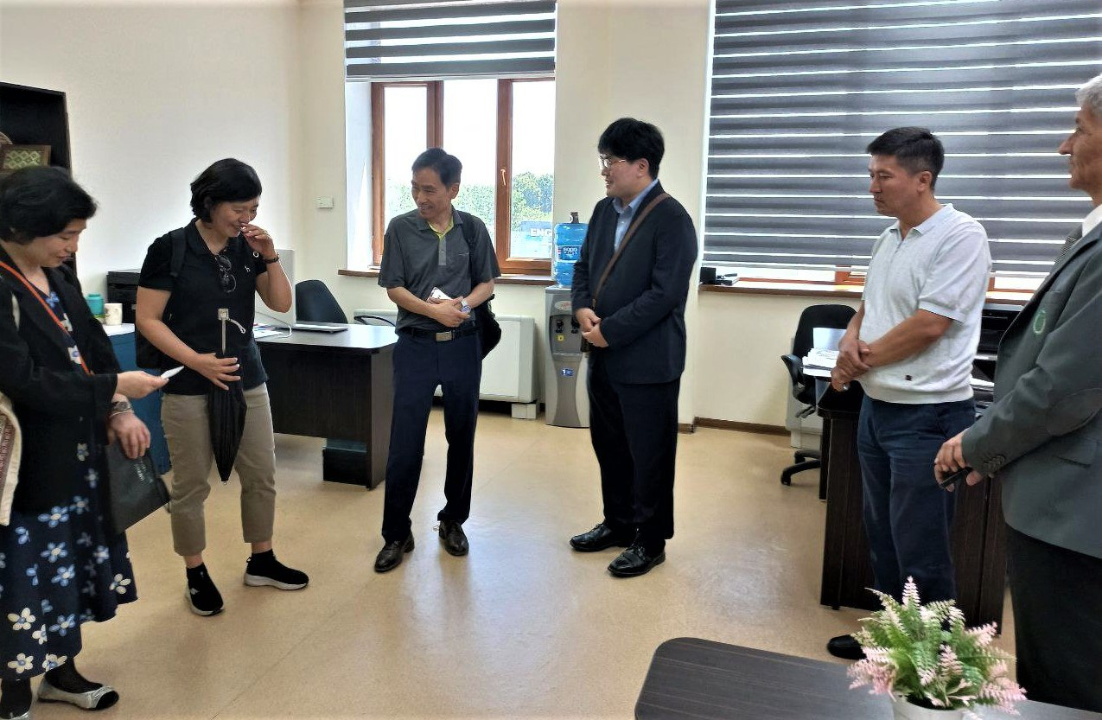

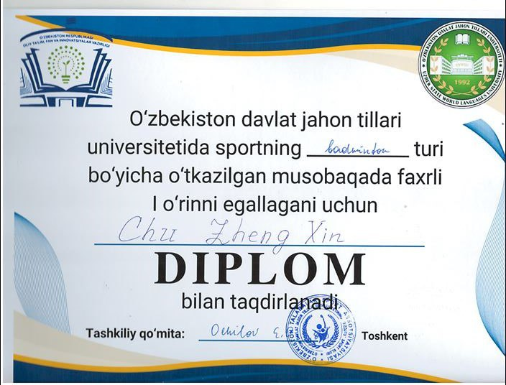

Head of the International Cooperation Department X. Yuldashev

