Lesson plan: Family values

Course title: Speaking
Topic: Family tree, upbringing children family celebration
Level: B2

Objectives: To introduce the topic family values
Time: 80 min

Activity | Objective |  | Procedure | Time | Mode of interaction |  | Materials
Warm up activity | Revision of previous knowledge |  | Teacher asks some questions about words of family and makes brainstorming on the whiteboard | 5 minutes | Whole group |  | Whiteboard and marker
Pre- | Teacher introduces the topic  Family values |  | Students get acquainted with family tree, upbringing children and family celebration with the presentation and information given by teacher | 10 minutes |  | Whole group | Laptop and TV
While- | 1.Teacher represents new vocabulary with the pictures on the screen |  | Teacher explains words which are used in family | 10 minutes |  | Whole group | Laptop and projector
 | 2.Students learn the new vocabulary and do matching activity  3.Students show the video which is prepared for the lesson by them |  | Teacher gives handouts to students and they should match pictures with names  They prepared speech about world food | 15 minutes  15 minutes |  | Pair work  Group work | Handout 1  Laptop, TV, Whiteboard and posters
Post- | Students make draw family tree |  | Students work in groups and prepare their little project | 20 minutes |  | Group work | Family tree
Homework: | Students are given text about Family volues |  | Teacher recommends to read and retell | 5 minutes |  | Whole group | Handout 3

Warm up questions.
- How many brothers and sisters do you have?
- Are you an only child?
- Do you have younger or older brother/sister?
- Are your parents still living?
- What are the best things you have learned from your parents?
- Are you married or single?
- Do you have any children?
- How big your family?
- Who is the oldest person in your family?
- Who is the funniest person in your family?

Pre….. Family values
Family values are the core beliefs and priorities that shape how a family interacts, makes decisions, and handles challenges, ultimately influencing the development and behavior of family members. These values can be broadly categorized into principles like love, respect, honesty, integrity, and responsibility. They are often passed down through generations and can be influenced by cultural, religious, or personalexperiences.
While…..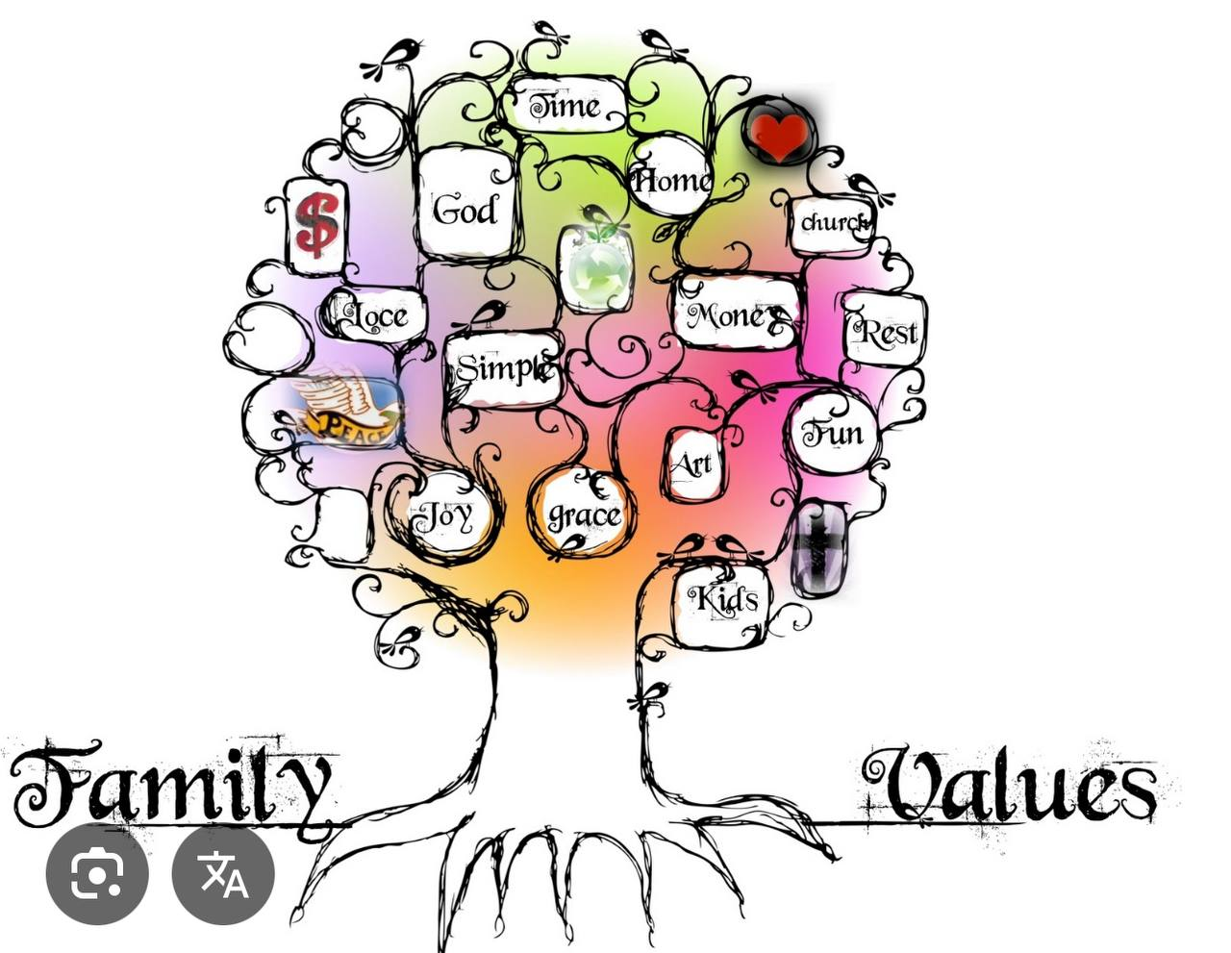
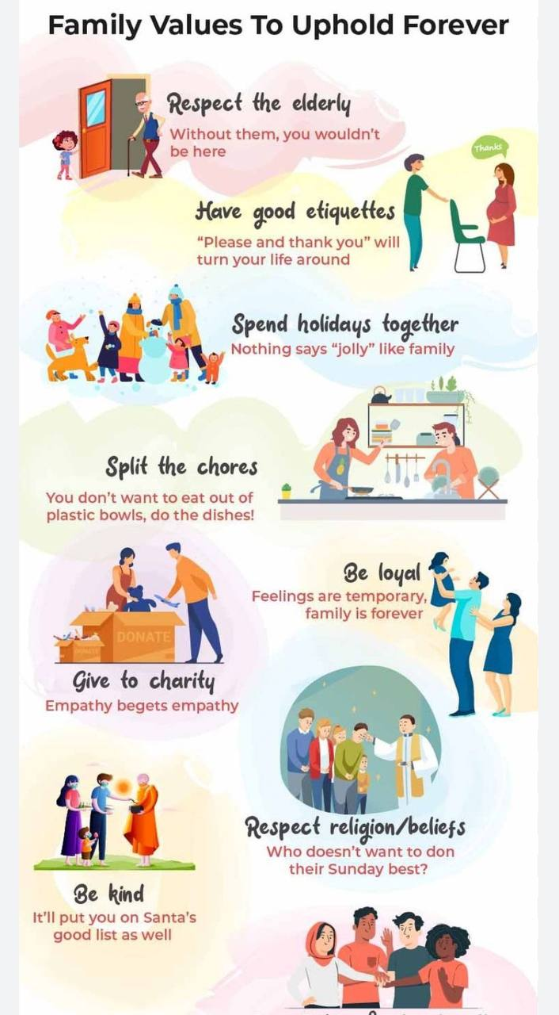
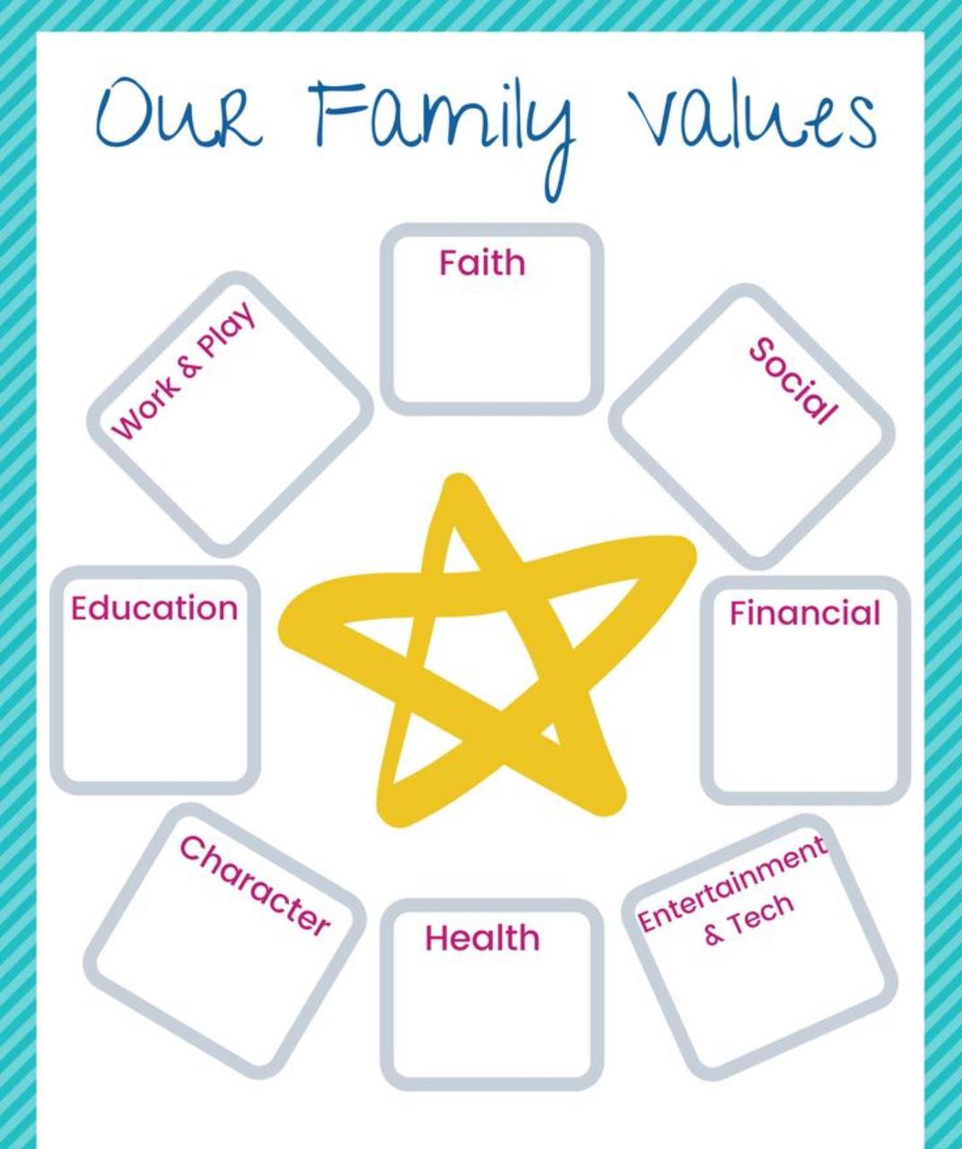

Homework. Read and retell
Why Are Family Values Important?
The phrase “family values” often brings to mind a heteronormative nuclear family: a husband, a wife, and their adopted or blood offspring. Today’s families take many forms due to economic pressures, growing acceptance of LGBTQ relationships, shifting demographics, and other causes.
A few recent trends in family and household structures include:
• Cohabitation without marriage: Many unmarried couples now live together. As of 2019, 59% of American adults aged 18 to 44 have lived with a partner without marriage.
• Multigenerational households: Extended family members increasingly live together in one household. In 2022, the Pew Research Center reported that 25% of Americans lived in multigenerational households. Reasons for multigenerational cohabitation include cultural norms and financial security.
• Rise of child-free adults: The birthrate in the United States has declined in recent years, and many people embrace child-free lifestyles. In a 2023 Pew Research Center survey, 57% of American adults under the age of 50 reported that it’s “not too likely” or “not at all likely” that they will have children. That number rose 10% between 2019 and 2023

