**Report**

**on the Tasks Carried Out by the Psychologist of Uzbekistan State World Languages University During the 2023–2024 Academic Year**

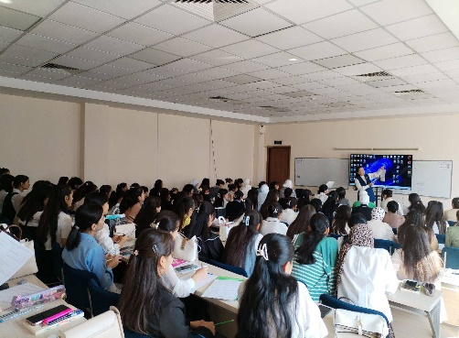 In order to become closely acquainted with newly admitted first-year students of the Uzbekistan State World Languages University and to provide full information about the psychologist’s socio-psychological activities and the types of psychological services, within the framework of the “1st-year school” events, the psychologist organized **15** roundtable discussions and seminar trainings in all faculties of the Higher Education Institution.

With the participation of the management of Uzbekistan State World Languages University and the psychologist, psychological master classes and trainings were organized for tutors. The tutors receive information on developing students’ socio-psychological passports. **10** seminar-trainings were held on the topic of “Culture of Communication and Behavior in Working with Students.”

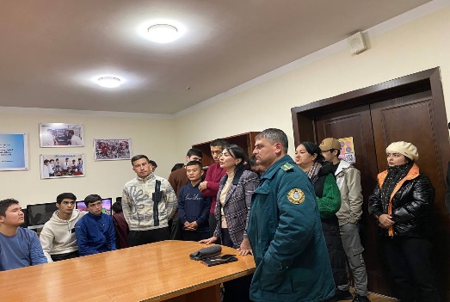 At Uzbekistan State World Languages University, methodologies to be used in creating the socio-psychological passport for the **2023–2024 and 2024–2025** academic years were prepared. Psychological methodologies were conducted in collaboration with tutors, and their results were re-processed. An electronic version of the socio-psychological passport was prepared.

Regarding work with students who have tendencies toward offenses and criminal behavior, during the **first quarter**, a “Pochebut Survey” was conducted. In the **second quarter**, either the “Hand Test” or the “Rosenzweig Test” was administered.

**19** psychodiagnostic sessions were conducted with students residing in the student dormitory and those living in rental accommodations.

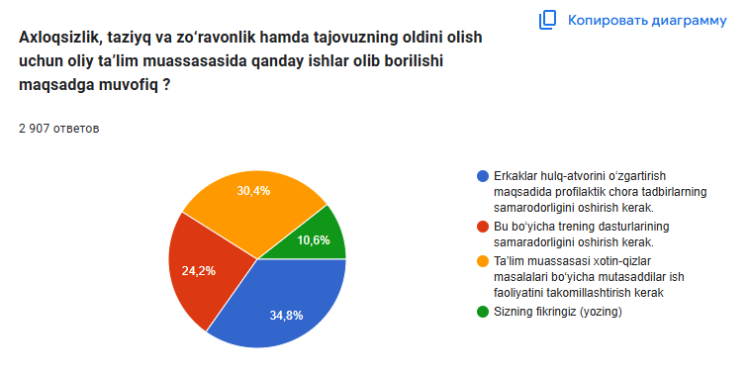**26** psychological motivational training programs were carried out to identify students with suicidal tendencies. For **first-year** students, the “**Sung Questionnaire**” and the “**Express Scale for Identifying Neurasthenia**” were administered. The results were analyzed.

Anonymous surveys were conducted regarding cases of violence and harassment among female students. A total of **2,907** students participated in the survey. The results were analyzed, and necessary recommendations were provided.

A series of measures were implemented to help students adapt to specific conditions, eliminate neurotic conditions, and work with students who are difficult to guide, as well as with their parents and tutors on an individual basis. Furthermore, to assess the group’s psychological climate, the “Method for Determining the Psychological Climate in a Group” was conducted. “Art therapy” and “Music therapy” sessions were held **9** times.

**8** training sessions were organized to implement measures aimed at alleviating the psychological strain and job-related fatigue experienced by the professors and staff of Uzbekistan State World Languages University, as well as to study the psychological roots of potential conflicts, analyze the motivations that cause them, and take measures to resolve them.

In order to further enhance the activities of the tutors at Uzbekistan State World Languages University and diagnose their psychological condition, a psychodiagnostic analysis was conducted on the topic “Psychological Stress Assessment Scale” to improve their knowledge, skills, and competencies. A survey titled “The Tutor Through the Student’s View” was carried out and analyzed.

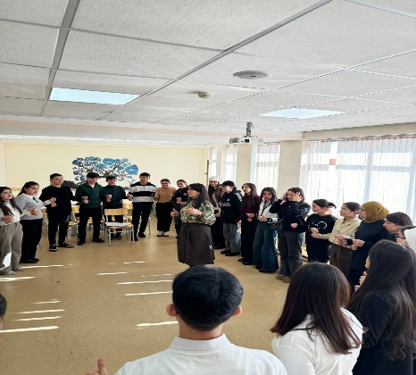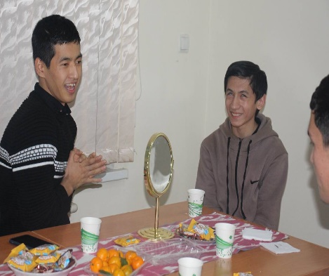 In order to create a “Barrier-Free Environment” for socially vulnerable students and those with disabilities—to help them adapt to society and their surroundings, continue their education, develop pedagogical and psychological measures for correctly organizing “Inclusive Education”, provide mental support, and offer them psychological assistance – **2** psychological training sessions and **24** individual consultations were conducted.

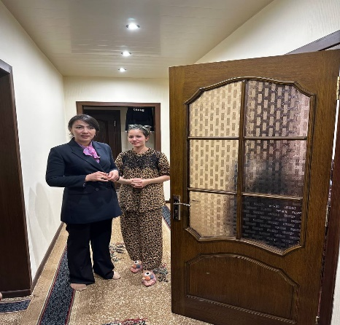Among students, to prevent situations that lead to conflicts and negatively affect their mental state (such as drug addiction, carefree lifestyle, smoking, alcoholism, gambling, and computer game addiction) and to strengthen propaganda against mass culture, **6** training sessions were carried out.

Within the psychodiagnostic process, **63** individual and group consultations and sessions were held with students regarding the problems identified.