**On the Chess Tournament Held within the Framework of the "Youth month"(Yoshlar oyligi) Organized by the Primary Organization of the Youth Union at Uzbekistan State World Languages University**

**AGENDA:**

**March 2025 Tashkent City**

**Chairperson:**

**V. Sadiyev – First Vice-Rector for Youth Affairs and Spiritual-Educational Work**

**Participants:**

V. Sadiyev – First Vice-Rector for Youth Affairs and Spiritual-Educational Work D. Khamdamov – Head of the Department for Youth Affairs, Spirituality and Enlightenment Coordinators of the Primary Organization of the Youth Union Lecturers from the Department of Physical Education and Sports Deputy Deans and Tutors

**AGENDA:**

1. Organization of the Chess Tournament within the framework of the "Youth Week" held during the "Youth Month" at the university.

2. Feedback on the competition and awarding the winners.

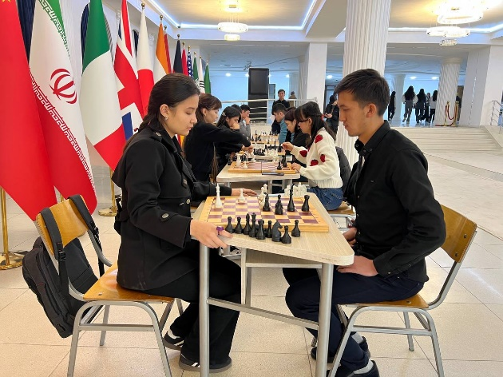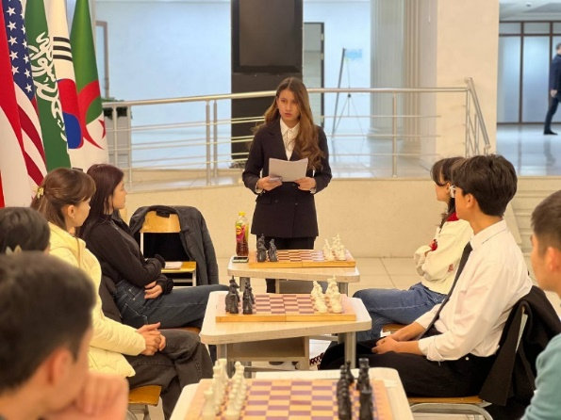DISCUSSION:

As part of "Youth Week," organized under "Youth Month," a Chess Tournament was held. From February 25 to March 25, 2025, the period was declared as "Youth Month" at Uzbekistan State World Languages University by the Primary Organization of the Youth Union.

The primary objectives of this month were to enhance youth intellectual potential, increase interest in sports, and develop logical thinking and quick decision-making skills.

Within this initiative, the Youth Union organized a university-wide Chess Tournament. The tournament aimed to develop students’ sporting potential, enhance strategic thinking, and create a friendly competitive environment among students. The main purpose of the competition was to encourage students to engage in chess and improve their skills in logical and strategic decision-making.

The event was officially opened by V. Sadiyev, who introduced the participants to the competition regulations. In his speech, he emphasized the importance of chess in developing both physical and mental abilities and highlighted the necessity of organizing such events among youth. He also mentioned famous world chess champions.

During the tournament, participants were encouraged to play fairly and in a spirit of friendly competition.

Participants demonstrated their knowledge, quick thinking, and decision-making skills. The games were conducted in an atmosphere of camaraderie, knowledge exchange, and intellectual cooperation.

Participants shared their impressions and suggested that such tournaments be held regularly and with broader themes.

At the conclusion of the tournament, the best performers were evaluated by a panel of judges based on the criteria set out in the regulations.

**DECISION:**

**The Organizing Working Group Resolves:**

1. According to the results of the tournament, the following participants were declared winners:

1st Place – Ozodakhon Oblaqulova (Faculty of Evening and Part-Time Education)

2nd Place – Akobir Qurbonov (Third English Faculty)

3rd Place – Ulug’murod Amirqulov (Faculty of English Philology)

Based on the Rector’s Order No. 85/11-08 dated February 22, 2025, the 1st, 2nd, and 3rd place winners (as per the attached list) shall be awarded diplomas by the university.

Additionally, in accordance with the regulations, the 1st place winner shall receive a financial incentive equivalent to three times the basic scholarship amount, the 2nd place winner – two times, and the 3rd place winner – the amount of one basic scholarship. These incentives will be granted from the university’s incentive fund, which is formed from both budgetary and non-budgetary (contract-based) sources.

2. Going forward, the university's sport-related initiatives shall be expanded. Chess tournaments will be organized regularly to enhance students’ logical thinking and sporting potential.

3. The university chess team shall be supplemented with new members selected from among the top-performing students, and their training for future competitions shall be continued.

Head of the Working Group: V. Sadiyev

Secretary: M. Sabirov